**Capacity building event on biomimicry in Porto, July 1 – 3, 2025**

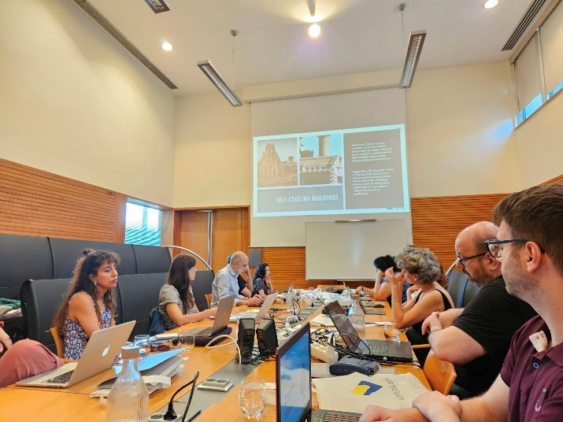

The Department of Electrical and Computer Engineering of the University of Thessaly, and specifically the Creative Technologies Learning Lab (<http://ctll.e-ce.uth.gr>) research team, co-organized an educational action for teachers, researchers and scientists on the promotion of the ability to innovate inspired by nature through a biomimicry methodology, a pioneering design method based on natural models and processes aimed at introducing sustainable solutions. The action took place in Porto, Portugal, between 1 and 3 July 2025, with the participation of 15 scientists from Romania, France, Spain, Portugal, Turkey and Greece.

The training program was carried out in the framework of the research project Let's Mimic: Biomimicry Design for Sustainability Skills in VET, which equips students with the creative and practical skills needed for the green transition by drawing inspiration from time-tested models, processes, and strategies of the natural world. Through experiential learning, digital collaboration tools and interdisciplinary educational content, the project empowers VET learners and teachers to apply nature-inspired thinking to real-world design, technology and sustainable development challenges. By integrating biomimicry into the learning process, the project enhances technical and analytical skills and cultivates a culture of ecological intelligence and systems thinking. In a world that immediately requires sustainable solutions, the project prepares the new generation of professionals to create in harmony with, and not in opposition to, nature.

Participants in the educational action had the opportunity to familiarise themselves with rich educational content concerning examples of problems that have been addressed with biomimicry, as well as open challenges that encourage students to follow biomimicry to design their own innovative proposals. They applied the design steps of biomimicry, such as define, biologise, discover, abstract, emulate, and evaluate. They participated in experiential actions with the practical application of full training modules developed for the application of biomimicry in learning and used the project's digital platform for innovative education in biomimicry.

The Let's Mimic research project is funded by the Erasmus+ program through the Hellenic National Authority IKY.