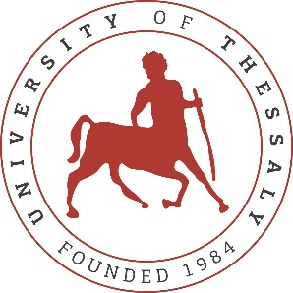

**PRESS RELEASE**

**Seminar on circular practices in tourism for students of the Public Post Secondary Vocational School of Volos at the Department of Electrical and Computer Engineering**

The Department of Electrical and Computer Engineering at the University of Thessaly, specifically the Creative Technologies Learning Lab (http://cttl.e-ce.uth.gr) research group, organised an experiential seminar on circular practices in tourism for students of the Public SAEK of Volos who visited the Department on May 19, 2025.

The audience participated in a discussion on the general practices of the circular economy, moving away from the non-long-term sustainable model of linear production, use, and disposal, aiming to reduce waste and maximise the use of natural resources. Afterwards, the participants discussed good practices of circular economy in tourism, which is a vital economic sector of our country, such as saving water, using renewable energy sources, avoiding food waste, avoiding the use of single-use products, limiting carbon dioxide emissions related to travel, using local products in catering, cooperation with suppliers that follow circular practices, the upgrade of products through good quality materials that extend their lifespan, reuse, recycling, the digitisation of services such as booking and payments, to save resources, promote tourism in a way that respects the environment, and encourage the participation of the local community in circular practices. The students watched videos with examples of circular actions in small tourism businesses both in Greece and abroad, identified good practices, and proposed their ideas for further promoting green and environmentally friendly tourism.

The action was carried out in the framework of the research project c-Tour: Circular Mindsets for Sustainable Small Tourism, funded by the Erasmus+ program of the European Commission. The research project develops digital vocational education and training interventions for the circular and green transition in tourism, contributing to broader efforts to combat climate change through ecologically responsible activities in the economy. It is aimed at small and medium-sized tourism businesses to develop skills and knowledge that facilitate the identification of opportunities and active participation in actions for the ecological improvement of daily business practices.

In addition to the University of Thessaly, educational organisations from Sweden, Romania, the Netherlands, Denmark, Ireland, and Portugal are participating in the research project.