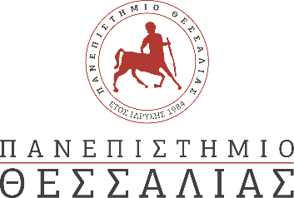

PRESS RELEASE

The CRT Student Team of the University of Thessaly won 3rd place in the FSA 2023 competition
The Centaurus Racing Τeam (CRT) of the University of Thessaly won the 3rd prize trophy of the Formula Student Austria FSA 2023 competition. In the event, which took place in the Red Bull Race Track in Spielberg, Austria (22- 27 July), the CRT ranked in 3rd overall position, amongst 21 international student teams. The CRT Team finished in 3rd place in the demanding Endurance Event of the competition and won 2nd and 3rd places in the categories of Cost Analysis and Design respectively.
Information regarding the FSA 2023 competition and the final results may be found in the following link: https://fsaustria.at/fsa-2023/results/
