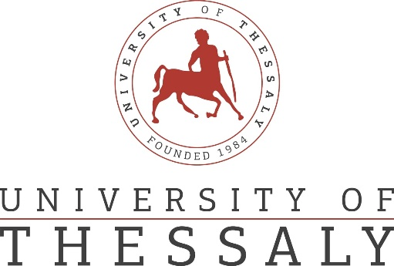

PRESS RELEASE

Workshop: Innovative Thinking for Sustainability
The Regional Center of Educational Planning of Thessaly and the Creative Technologies Learning Lab (http://ctll.e-ce.uth.gr) of the Department of Electrical and Computer Engineering of the University of Thessaly organize a workshop entitled "Innovative Thinking for Sustainability". The workshop will take place at the Tsalapatas Multiplex, Multipurpose Hall on Thursday, May 5th from 11.00 to 13.00. Registrations will start at 10.30. The workshop addresses secondary education teachers and students.
The audience will participate in experiential activities that apply in practice design thinking, a deeply anthropocentric methodology that aims to introduce innovative solutions to modern challenges through processes of empathy, problem research, re-definition of the problem, ideation, prototype design, and evaluation of solutions. More specifically, participants will apply design thinking to introduce innovative solutions to contemporary problems related to sustainability and environmentally responsible behaviour. In addition, they will delve deeper into how design thinking can be applied in learning to raise awareness, build knowledge and practical skills, and encourage responsible behaviour on sustainability issues. At the end of the event, audience members will receive a certificate of participation.
The workshop is organised within the framework of research project DT4S: Design Thinking for Sustainability Education (https://dt4s.eu/) funded by the Erasmus+ programme of the European Commission. In addition to the University of Thessaly, educational organizations from Estonia, Romania, Portugal, and Turkey participate in the project, which is implemented from 2019 to 2022.

