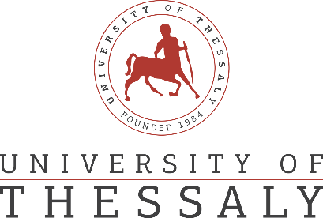

PRESS RELEASE

EmpathyinHealth Mutliplier Event

The University of Thessaly, Physiotherapy Department is participating in the project ‘Curriculum Development using VR technology to enhance empathetic communication skills in future health care professionals’ (EmpathyInHealth) which is funded by the Erasmus+ programme (KA203 Strategic Partnerships for higher education). The main aim of EmpathyInHealth is to create a curriculum for empathetic skills development in healthcare practitioners and home carers based on up to date evidence and cutting edge technology tools.
On Wednesday, July 27, 2022 the team delivered the ‘EmpathyinHealth Mutliplier Event’. A number of stakeholders were invited to attend the event namely academics from all relevant departments of higher education institutions in Greece, members of relevant scientific societies , members of patient organisations and decision makers from the Ministry of Health. The event started with an introduction to the scope of the project and an overview presentation of the project results. This was followed by a brief presentation and taster of the project materials (Interactive activities, Educational videos, Role Plays and VR videos). At the end, the participants had the opportunity to discuss the implementation of the project curriculum in training programmes for students and health professionals in empathy skills and exchanged ideas on how to further develop empathy training for patients and the general public.

