UNIVERSITY OF THESSALY SELECTED TO HOST Greek Diaspora Fellows

Collaborative Project will focus on various scientific fields

Greek Diaspora Fellowship Program to Support Projects at Universities in Greece
Volos, Jan. 2020 – University of Thessaly was selected by the Greek Diaspora Fellowship Program (GDFP) to host seven scholars from the United States and Canada to work on seven collaborative projects covering various scientific fields:
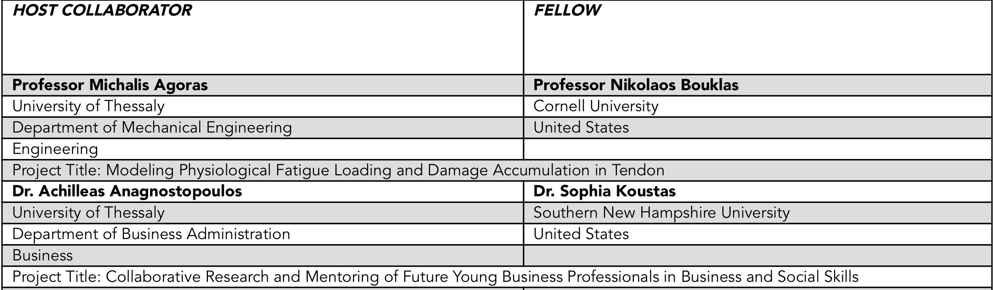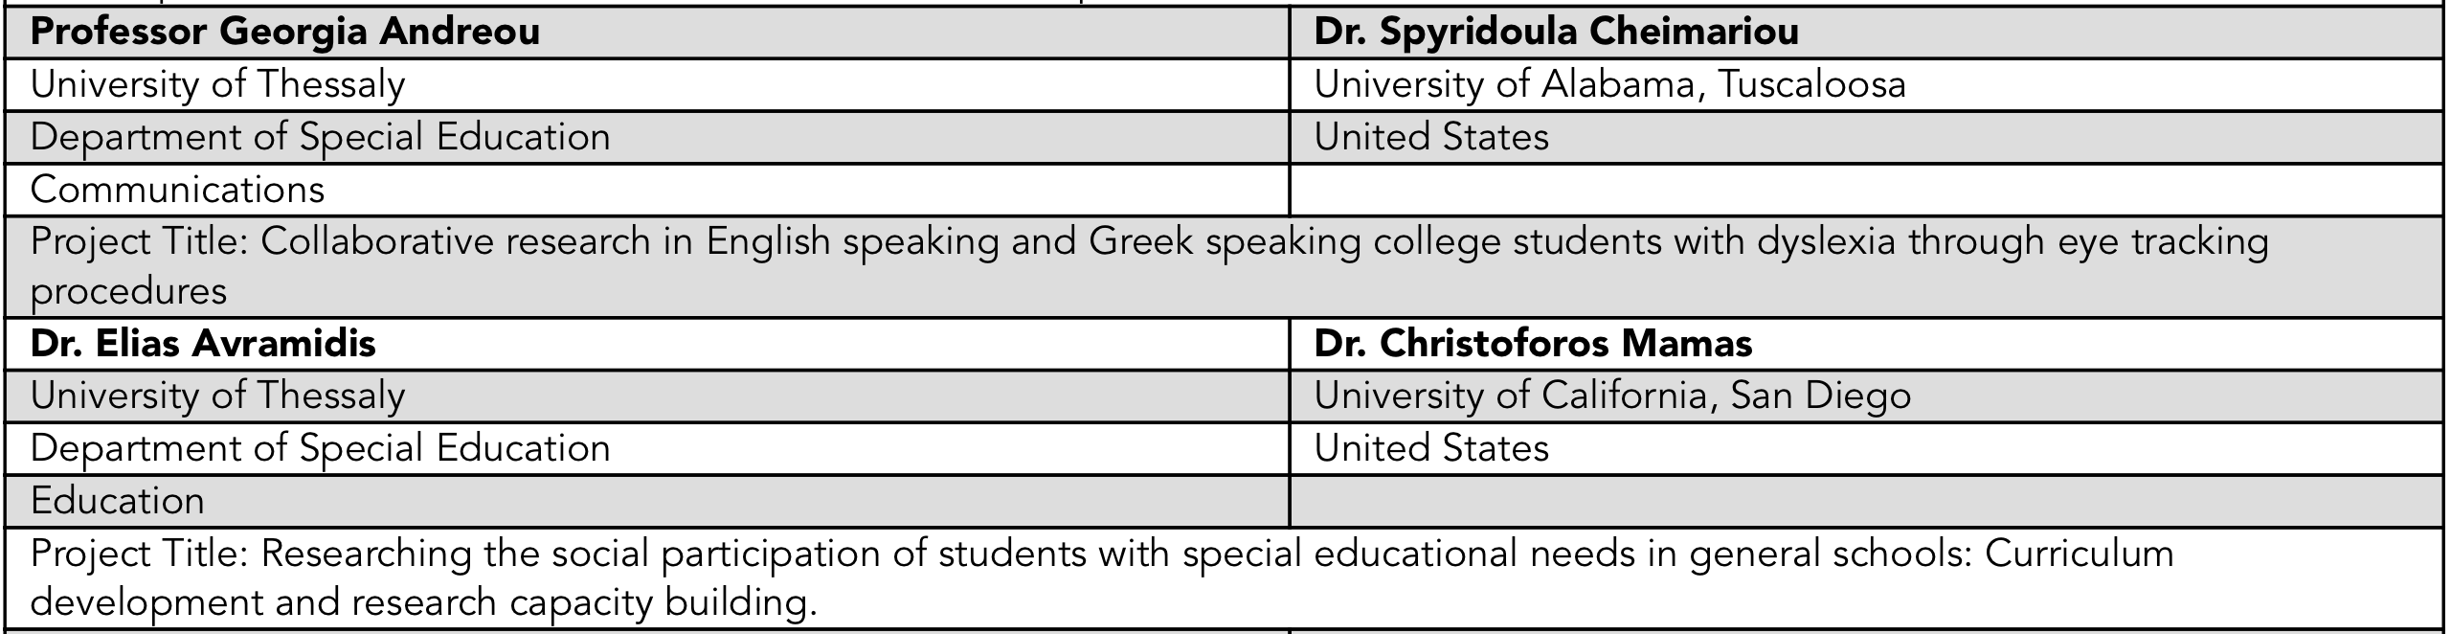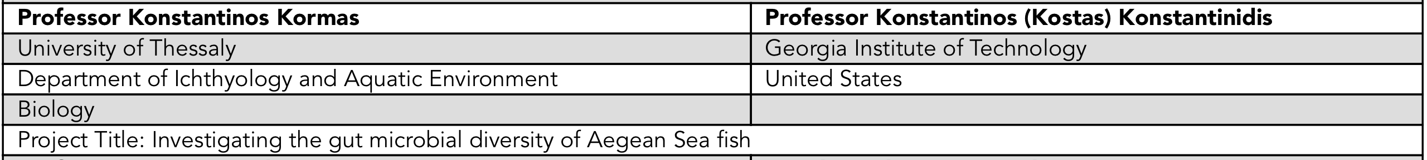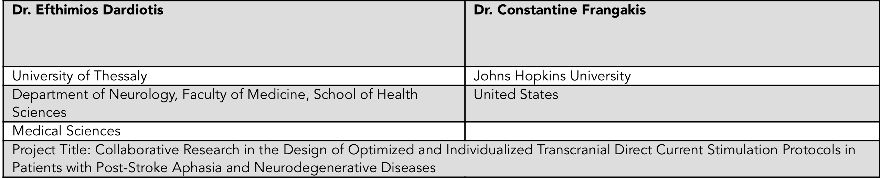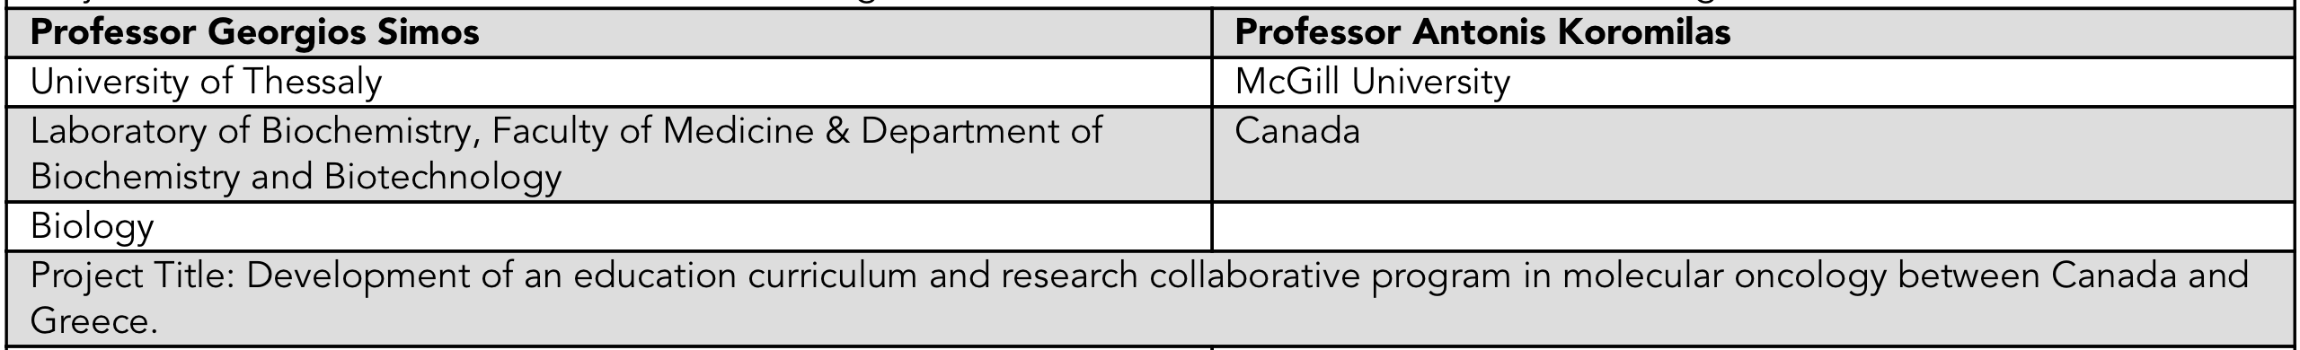
The above mentioned projects of the University of Thessaly are seven of the 38 projects that will pair 38 members of the Greek and Cypriot academic diaspora with higher education institutions and collaborators in Greece to work together on curriculum co-development, collaborative research, graduate and undergraduate research training and mentoring activities in the coming months.
The GDFP, now in its third year, is designed to enable brain circulation between Greek universities and universities abroad, strengthen capacity at the host institutions, and develop long-term, mutually-beneficial collaborations. It is funded by the Stravros Niarchos Foundation (SNF) and managed by the Institute of International Education (IIE) in collaboration with the Fulbright Foundation in Greece. A total of 87 Fellowships have been awarded since the program’s inception.
Fellowships match host universities with scholars and cover the expenses for project visits of between 14 and 90 days, including transportation, a daily stipend, materials allowance and health insurance.
A complete list of projects can be found here.
Please direct all questions related to the application process to GreekDiaspora@iie.org.
Connect with the GDFP:

