https://www.uth.gr/academicnews/nea-diadikasia-feb-2020-gia-pragmatopoiisi-praktikis-askisis-ektos-espa-gia-spoydastes-toy
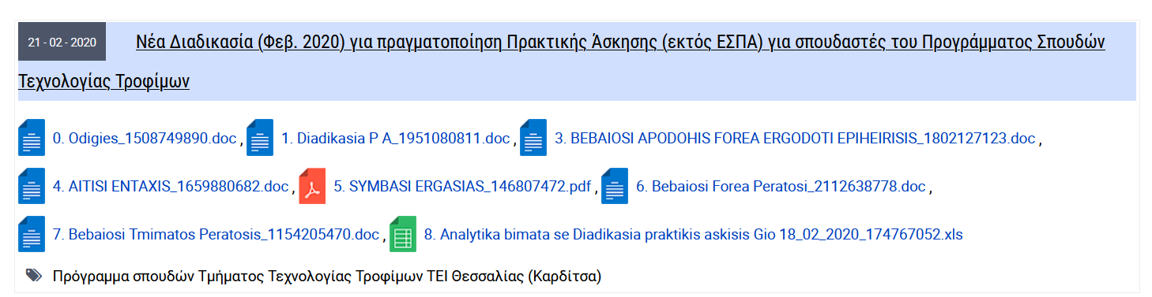

https://www.uth.gr/academicnews/stoiheia-gia-foreis-poy-ehoyn-ekdilosei-endiaferon-gia-apasholisi-foititon-toy-ps-tehnologias
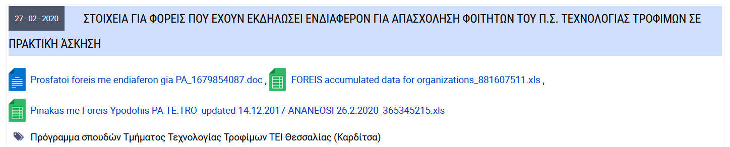

https://www.uth.gr/academicnews/praktiki-askisi-espa
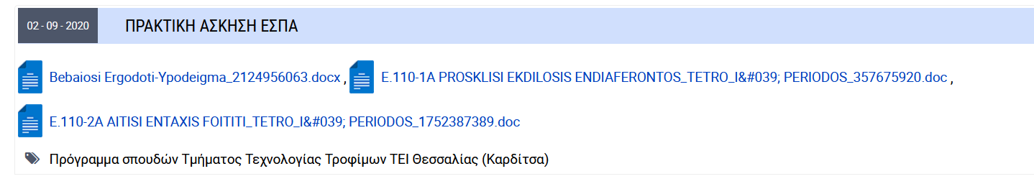

https://www.uth.gr/academicnews/praktiki-askisi-1
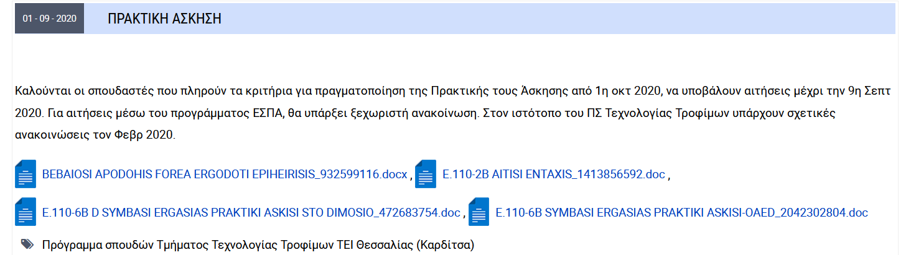

https://www.uth.gr/academicnews/praktiki-askisi-me-tile-ergasia
